Design Document: Migration to RSA256 & Key Rotation for JWT signature (MIDAS project)
Version: 1.0
Author: Oleg Kleiman
Project: MIDAS / Digitel Ovdim
Date: 2025-11-16

Introduction
This document presents the proposed design for implementing secure JWT signing and automated key rotation as part of the MIDAS project. The goal is to modernize and secure the existing token-issuing mechanism by leveraging Azure Key Vault, Managed Identity, API Management, and .NET 8.
The scope includes improvements to token generation, signing, validation, and consumption, without requiring major changes to the existing Mobile Server or Mobile Application once the solution is implemented.

Background and Motivation
The current token-signing implementation relies on manually managed keys, with no automated rotation mechanism and limited observability.
To meet modern security standards and comply with internal governance, the JWT issuer must use secure, centrally managed signing keys with automated rotation.
Azure Key Vault offers native support for RSA-256 key generation and rotation, making it a natural choice for improving the signing and validation workflow.
In addition, modernizing the Midas service to .NET 8 enables:
- native Managed Identity support,
- improved performance and stability,
- Modernization and standardization across the organization.

Scope

In Scope

Implementing automated RSA-256 key rotation in Azure Key Vault.

Updating the JWT issuer to:

Run under Azure Web App with Managed Identity,

Access Key Vault securely,

Expose updated endpoints:/token, /token_info, /refresh, /validate_token.

Implementing server-side JWT validation using Key Vault keys.

Updating Mobile Service access via Azure API Management with JWT validation policies.

Migrating the OAuth server to .NET 8.

Establishing CI/CD pipelines for the updated solution.

Testing and verification of end-to-end authentication flow.

Out of Scope
- Changes to the Mobile Application (beyond the expected automatic compatibility).
- Redesign of the Mobile Server authentication logic beyond APIM integration.
- User identity model changes (no changes to claims structure other than signing method).
- Migration to asymmetric validation on the Mobile Server side (relying instead on APIM).
- Any unrelated updates to OAuth logic, user provisioning, or existing data flows.

Objectives
- Introduce secure, automated signing-key rotation for JWTs.
- Ensure tokens are signed and validated using industry-standard RSA-256.
- Enhance security by leveraging Azure Managed Identity and Key Vault.
- Centralize validation via Azure API Management.
- Modernize the OAuth server to .NET 8 with DI and improved architecture.
- Minimize ongoing maintenance and manual key-handling operations.
- Ensure backward compatibility and stable operations for the Mobile ecosystem.

Proposed Architecture

High-Level Architecture Components
Azure Key Vault
- Hosts RSA-256 signing keys.
- Automatically rotates keys according to organization policy.

JWT Issuer (Midas Server, .NET 8, Azure Web App)
- Uses Managed Identity to securely access Key Vault.
- Issues tokens signed with Key Vault keys.
- Exposes endpoints:
/token, /token_info, /refresh, /validate_token.

Azure API Management (APIM)
- Validates tokens using Key Vault keys.
- Restricts access to Mobile Server endpoints.

Mobile Server
- Receives only APIM-validated requests.
- No internal JWT validation logic needed.

Detailed Design
- Assume Midas server is implemented on the .NET 8 platform. Do not implement this plan on older versions.

Step 1 — Key Rotation Setup
- Create RSA-256 keys in Azure Key Vault with rotation policy.
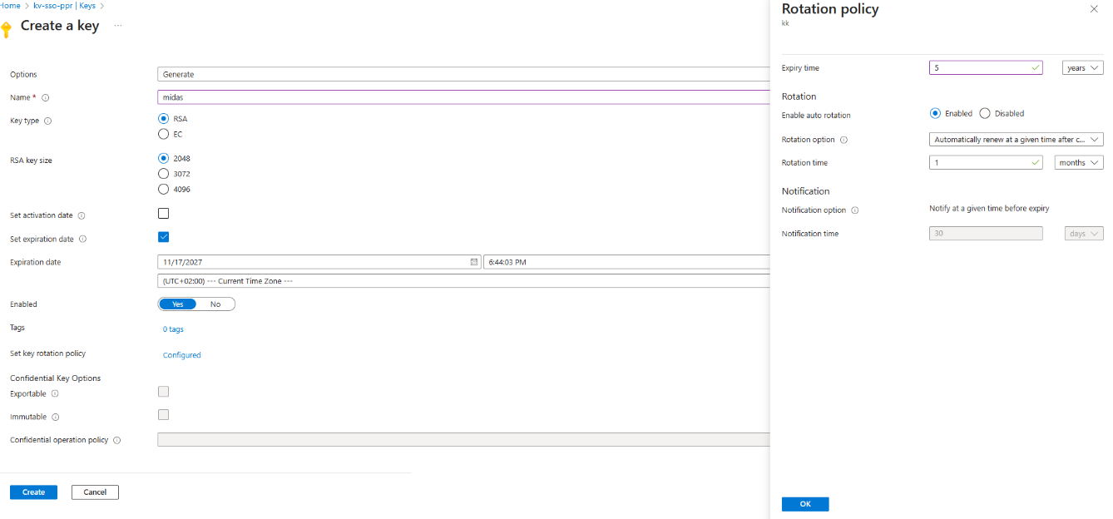

Step 2 — JWT Issuer Access to Key Vault
- Use the following from MIDAS Azure Registration
  - Clientid
  - TenantID
  - ClientSecret
- Store these values securely in the MIDAS Server configuration and use them to create client credentials to access Azure KeyVault:

var credentials = new ClientSecretCredential(tenantId,clientId,clientSecret);
var keyClient = new KeyClient(new Uri(issuerOptions.KeyVaultUrl), credentials);
KeyVaultKey key = await keyClient.GetKeyAsync(issuerOptions.KeyName);

- Grant MIDAS App Registration access to Key Vault via “Key Vault Crypto User” (for keys used by JWTs) and “Key Vault Secrets User” (for secrets used by refresh tokens) role
- Update MIDAS service to sign tokens directly via Key Vault cryptographic operations.
var securityKey = new KeyVaultRsaSecurityKey(key.Id.ToString());
var signingCredentials = new SigningCredentials(securityKey,
SecurityAlgorithms.RsaSha256)
{
CryptoProviderFactory = new CryptoProviderFactory
{
CustomCryptoProvider = new KeyVaultCryptoProvider()
}
};

The issued tokens look like:
{
"alg": "RS256",
"kid": "https://kv-sso-ppr.vault.azure.net/keys/HRKey/991fbd10cee44ae39efb0af24f083336",
"typ": "JWT"
}
{
"sub": "8320f951-b38f-4773-a51e-11dd4219269b",
"exp": 1763644878,
"iss": "urn:tel-aviv:api:issuer",
"aud": "midas-api"
}
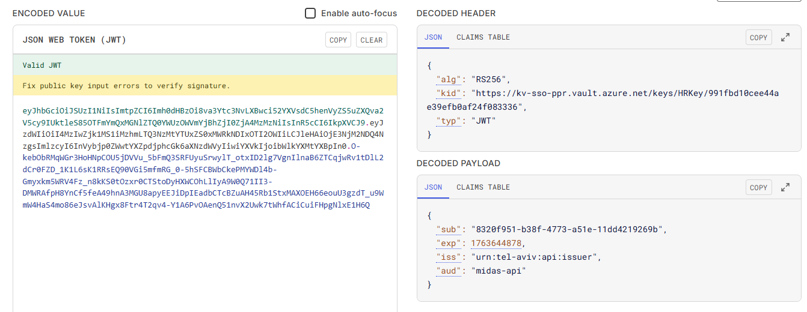

Step 3 — Server-Side JWT Validation
- Implement /validate_token endpoint using:
  - public part of the Key Vault key,
  - Built-in .NET 8 cryptography libraries.
- Validate
- signature,
- expiration,
- issuer,
- Audience.

Risks and Mitigations
Risk
Impact Mitigation
Key Vault downtime may block token issuance | Medium | Enable redundant Key Vault replicas, implement retry policies
Performance impact due to remote signing | Medium | Use local caching of key metadata; avoid excessive round-trips

Open Questions / Pending Items
- Should we maintain two signing keys active at all times for redundancy?
- Does Mobile Server require any backward compatibility for older JWT formats?
- What is the required rotation interval per security policy (30/60/90 days)?
- Should a fallback validation endpoint be provided?
- Will APIM operate using an internal Key Vault reference or JWKS endpoint?

Conclusion
The proposed architecture modernizes the JWT signing process, significantly enhances security, and reduces operational overhead through automated key rotation. By leveraging Key Vault, Managed Identity, .NET 8, and API Management, the solution ensures a robust, maintainable, and future-proof authentication pipeline for the MIDAS project and related services.
End of Document

